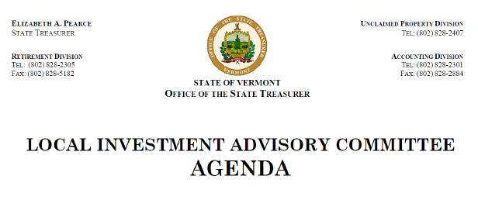
August 21st, 2018 – 10:00 am
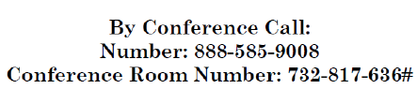
- Approval of Minutes
- Treasurer’s Update
- Discussion of Act 188 – Solicitation Draft
- Comment from members of the public
- Adjourn

